Refer the project first: P3a-SpringBoot-Kafka-Producer

Topic Name: demo1topic

We will consume the below 2 endpoints from the Producer:

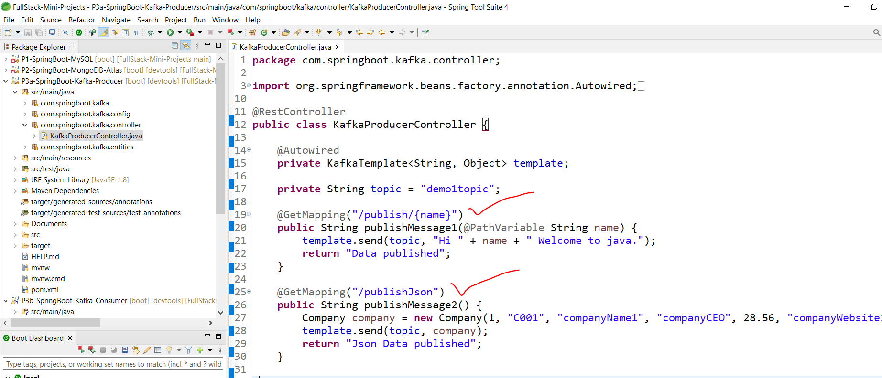

Copy then entity here:

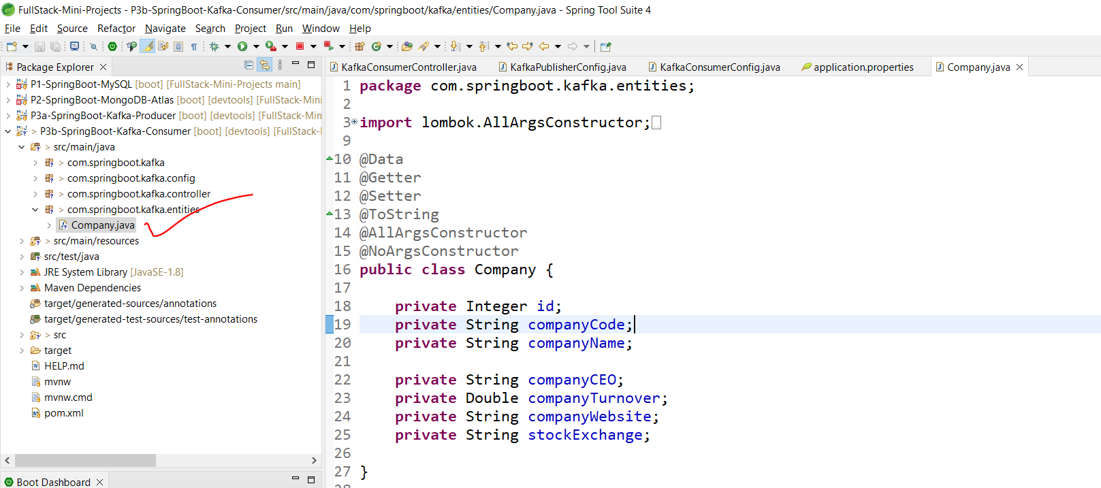

Check the new config in GitHub file:

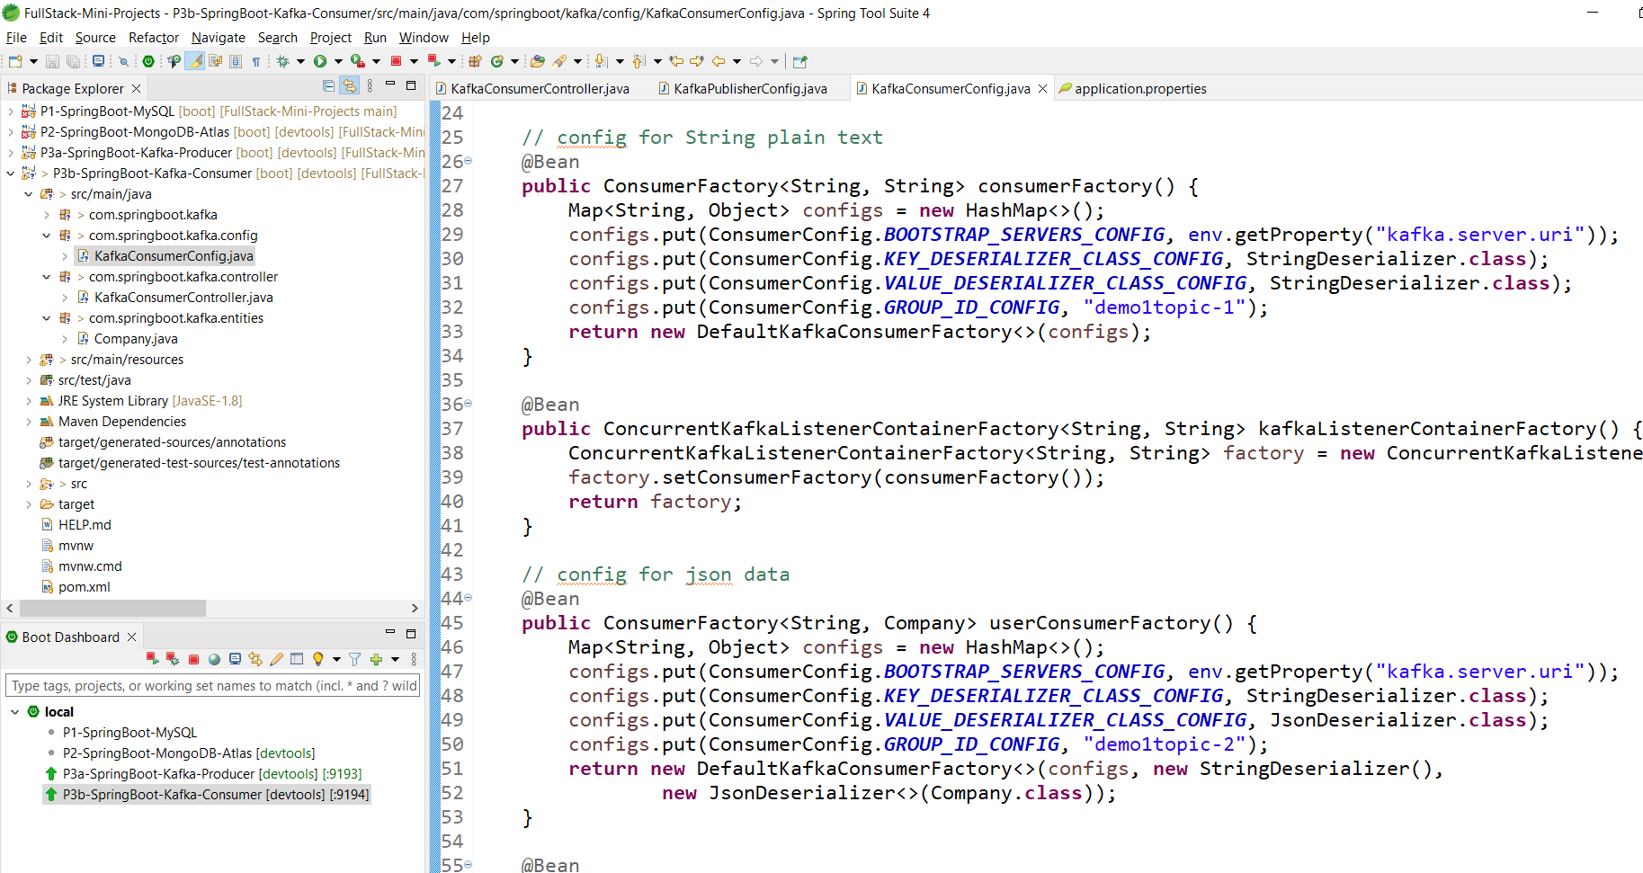

1 for plain string and 1 for complex object.

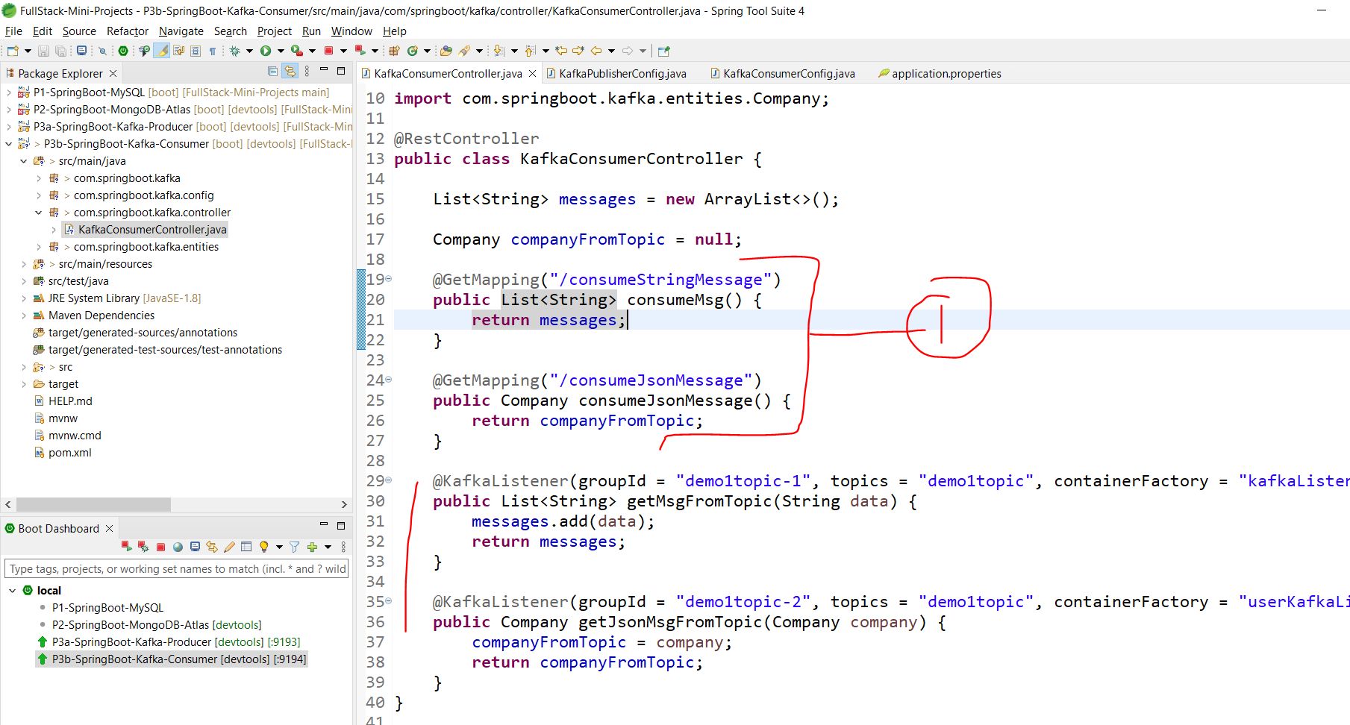

Point 1 will generally be not required as we can handle the events in the below endpoints. But we added it here just to check the output via postman.

